PPS Instructions:
- Open your preferred browser and enter https://pps.voice.isc.upenn.edu/ - you will need to authenticate with your PennKey credentials
- Your screen will then display your current VOIP phoneset settings (see below)
- Scroll down to Call Forward All
Enter the forwarding destination
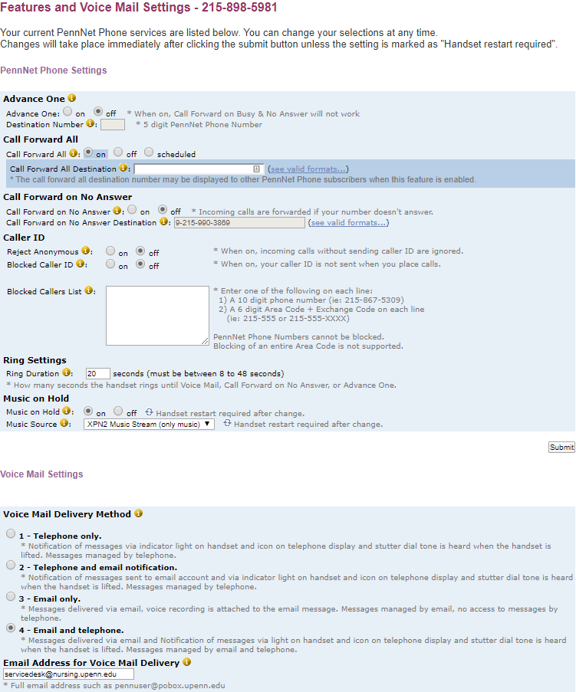
Enter your email address
- You can also enter your email address to select to have your messages delivered to your email account
- Click the Submit button to accept your changes

